/\*\*\*\*\*\*\*\*\*\*\*\*\*\*\*\*\*\*\*\*\*\*\*\*\*\*\*\*\*\*\*\*\*\*\*\*\*\*\*\*\*\*\*\*\*\*\*\*\*\*\*\*\*\*\*\*\*\*\*\*\*\*\*\*\*\*\*\*\*\*\*\*\*\*\*\*\*\*

Online Java Compiler.

Code, Compile, Run and Debug java program online.

Write your code in this editor and press "Run" button to execute it.

\*\*\*\*\*\*\*\*\*\*\*\*\*\*\*\*\*\*\*\*\*\*\*\*\*\*\*\*\*\*\*\*\*\*\*\*\*\*\*\*\*\*\*\*\*\*\*\*\*\*\*\*\*\*\*\*\*\*\*\*\*\*\*\*\*\*\*\*\*\*\*\*\*\*\*\*\*\*\*/

import java.util.\*;

public class Main

{

public static void main(String[] args) {

String b;

int a= 0;

int e= 0 ;

int i=0;

int o =0;

int u = 0;

Scanner s= new Scanner(System.in);

b=s.nextLine();

for(int j = 0;j<b.length();j++){

if (b.charAt(j)=='a')

{

a++ ;

}

else if (b.charAt(j)=='e')

{

e++ ;

}

else if(b.charAt(j)=='i'){

i++;

}

else if (b.charAt(j)=='o')

{

o++ ;

}

else if (b.charAt(j)=='u')

{

u++ ;

}

else{

}

}

System.out.println("No of a:"+a);

System.out.println("No of e:"+e);

System.out.println("No of i:"+i);

System.out.println("No of o:"+o);

System.out.println("No of u:"+u);

}

}

\

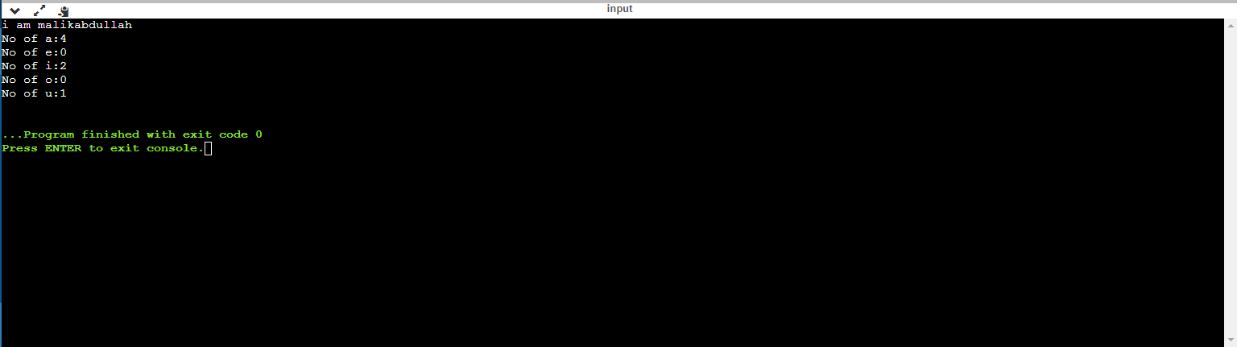

/\*\*\*\*\*\*\*\*\*\*\*\*\*\*\*\*\*\*\*\*\*\*\*\*\*\*\*\*\*\*\*\*\*\*\*\*\*\*\*\*\*\*\*\*\*\*\*\*\*\*\*\*\*\*\*\*\*\*\*\*\*\*\*\*\*\*\*\*\*\*\*\*\*\*\*\*\*\*

Online Java Compiler.

Code, Compile, Run and Debug java program online.

Write your code in this editor and press "Run" button to execute it.

\*\*\*\*\*\*\*\*\*\*\*\*\*\*\*\*\*\*\*\*\*\*\*\*\*\*\*\*\*\*\*\*\*\*\*\*\*\*\*\*\*\*\*\*\*\*\*\*\*\*\*\*\*\*\*\*\*\*\*\*\*\*\*\*\*\*\*\*\*\*\*\*\*\*\*\*\*\*\*/

import java.util.\*;

public class Main

{

public static void main(String[] args) {

int unit;

Scanner s = new Scanner(System.in);

do{

System.out.println("Enter units");

unit = s.nextInt();

ElectricityBill c = new ElectricityBill();

c.calculate(unit);

}while(unit!=0);

}

}

abstract class Bill{

abstract void calculate(int unit);

}

class ElectricityBill extends Bill

{

public ElectricityBill(){

}

@Override

void calculate(int unit){

if(unit==0){

}

else if(unit<=100){

int x = unit\*5;

System.out.println(x);

}

else if(unit<=200 && unit>100){

double z= (100\*5)+(unit-100)\*7.5;

System.out.println(z);

}

else if(unit>200){

double v = ((100\*5)+(100\*7.5)+(unit-200)\*10);

System.out.println(v);

}

else{

}

}

}

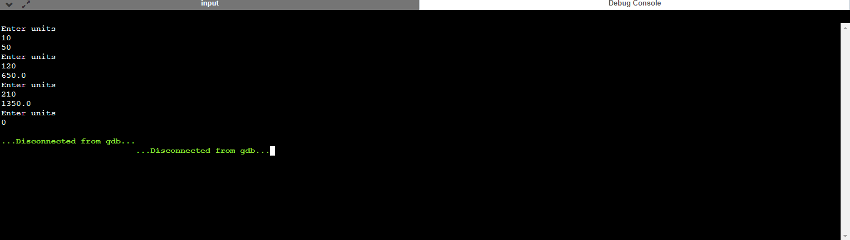

/\*\*\*\*\*\*\*\*\*\*\*\*\*\*\*\*\*\*\*\*\*\*\*\*\*\*\*\*\*\*\*\*\*\*\*\*\*\*\*\*\*\*\*\*\*\*\*\*\*\*\*\*\*\*\*\*\*\*\*\*\*\*\*\*\*\*\*\*\*\*\*\*\*\*\*\*\*\*

Online Java Compiler.

Code, Compile, Run and Debug java program online.

Write your code in this editor and press "Run" button to execute it.

\*\*\*\*\*\*\*\*\*\*\*\*\*\*\*\*\*\*\*\*\*\*\*\*\*\*\*\*\*\*\*\*\*\*\*\*\*\*\*\*\*\*\*\*\*\*\*\*\*\*\*\*\*\*\*\*\*\*\*\*\*\*\*\*\*\*\*\*\*\*\*\*\*\*\*\*\*\*\*/

import java.util.\*;

import java.io.\*;

public class Main

{

public static void main(String[] args) {

ArrayList<Integer> a = new ArrayList<>();

ArrayList<String> b = new ArrayList<>();

try{

FileInputStream fis = new FileInputStream("D://data.txt");

DataInputStream dis = new DataInputStream(fis);

while(true)

{

int book=dis.readInt();

String auther = dis.readUTF();

a.add(book);

b.add(auther);

}

}

catch(Exception e){

}

int count=0;

for(int i=0;i<b.size();i++){

if(b.get(i)=="pearson"){

count++;

System.out.println("book id:"+a.get(i));

System.out.println("Auther name:"+b.get(i));

}

else{

}

}

}

}